Notifications
Notifications and Subscribing to Discussions
The Notification tool allows users to receive instant email notifications about course activities such as grades, new discussion posts, upcoming quizzes, dropbox due dates and news items.

Setting Notifications
- To enable notifications click on your name located in the top right corner (1) and select Notifications (2).
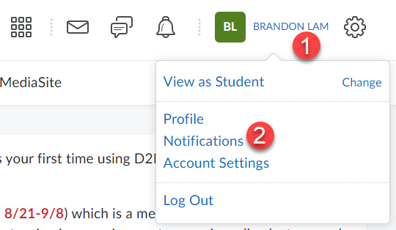

- Click Enable email notifications.
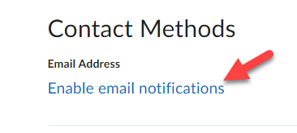

- Select the radio button for Use custom email: and enter an external email address [This can be different than that used for your Email forwarding option] (1). Click Save when done (2).
NOTE: A confirmation email will be sent to the email address you entered. You must follow the instructions in the email to confirm/verify your email address.
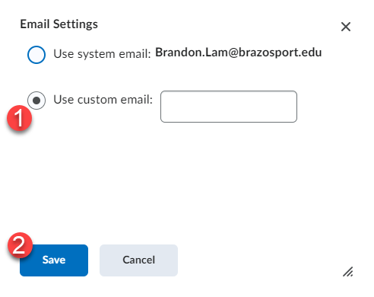

- Under the header for Instant Notifications, check the checkbox(s) for each instant notification you would like to receive.
Note: You MUST have enabled Email to check notification boxes.
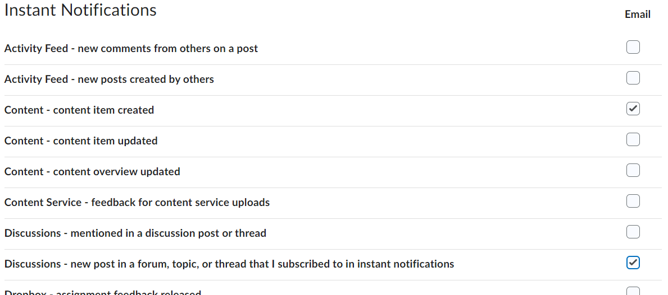

Note: If selecting to send an instant notification from Discussions you MUST enter the Discussions area and select to "subscribe" to a particular Forum or discussion topic to receive your notification.
- Under the header for Customized Notifications, make desired selections and click the Save button.
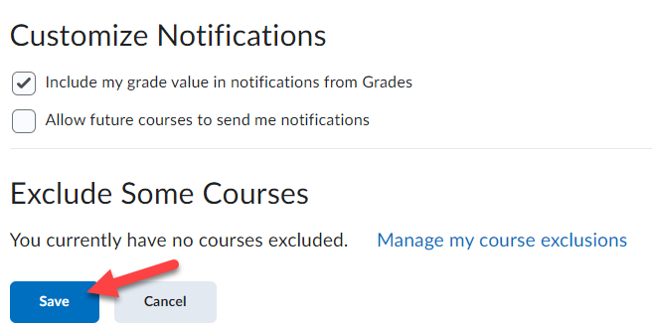

Notification Alerts
Notification alerts show new instant notification you subscribe to such as grades, news items, dropbox, quizzes, etc….
- Whenever you receive a new notification alert you will see an orange dot on the Update alerts icon located near the top right corner of the page.
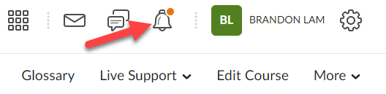

- Clicking on the icon will show you all the new updates/notifications you have received regarding the course.
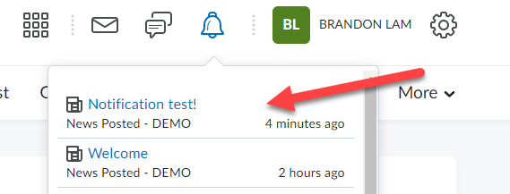

- Clicking on a notification alert from the list will take you to the Quiz, Dropbox, Grade, or News Item the specific alert is for.

Subscribe to Discussion
- To subscribe to Discussions, click on the drop-down menu next to the title of either a Forum (this will select ALL topics under the forum) or a particular discussion topic (1). Then select Subscribe from the list (2).
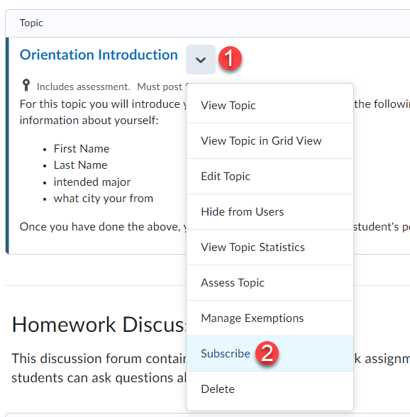

- Select the Send me an instant notification option for Notification Method (1) and then click on Subscribe (2).
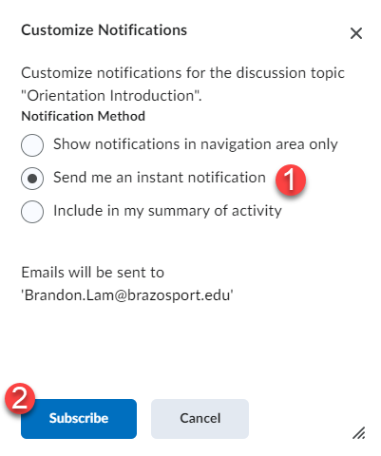

Chatter Alerts
Chatter alerts show new discussion posts in forums, topics, and specific message threads to which you have subscribed.
- Whenever you receive a new discussion notification you will see an orange dot on the chatter alert icon located near the top right corner of the page.
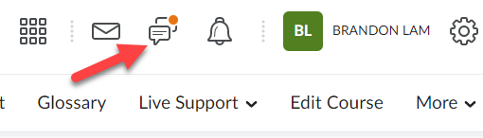

- Click on the chatter alert icon to view new postings to the discussions you have subscribed to.
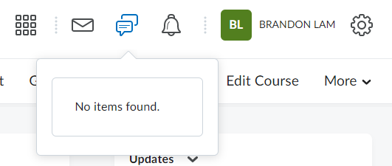

3. Clicking on the title listed in the chatter alert will take you to the forum, topic, and specific message to which you have subscribed.

