Desire2Learn allows you the option to edit your profile whenever you desire.
Working With Profiles
- Login to Desire2Learn (https://online.brazosport.edu).
- Click on your name (in the top right-hand corner of the page) and click on the Profile link.
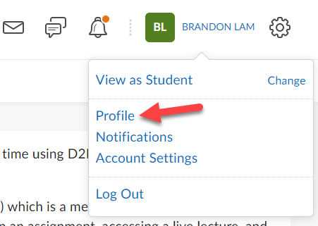

- Enter or edit any information on this page you would like. Do not provide private information since it is viewable to all course members. Entering profile information is optional. If you need to edit your profile picture proceed to the next Step. If not skip to Step 8.
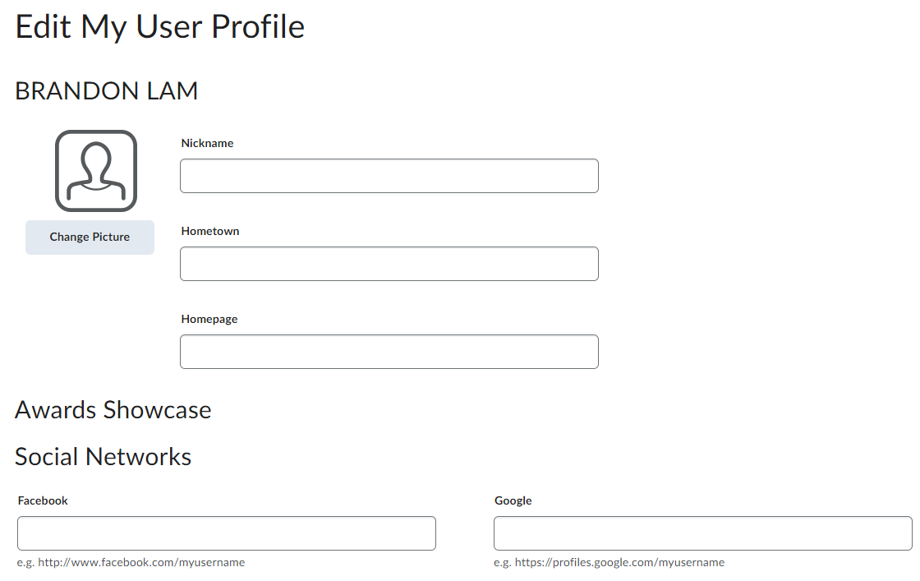

- Click the Change Picture button. You must already have an image saved on your computer. For best results the picture should be a headshot of yourself.
[IMPORTANT: The image you use MUST BE APPROPIATE for viewing.]
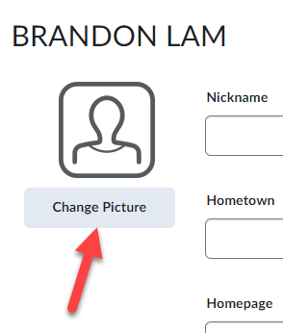

- Click on My Computer (1), then click on the Upload button (2), locate your image file (3), and then click on it once to select it and click the Open button (4).
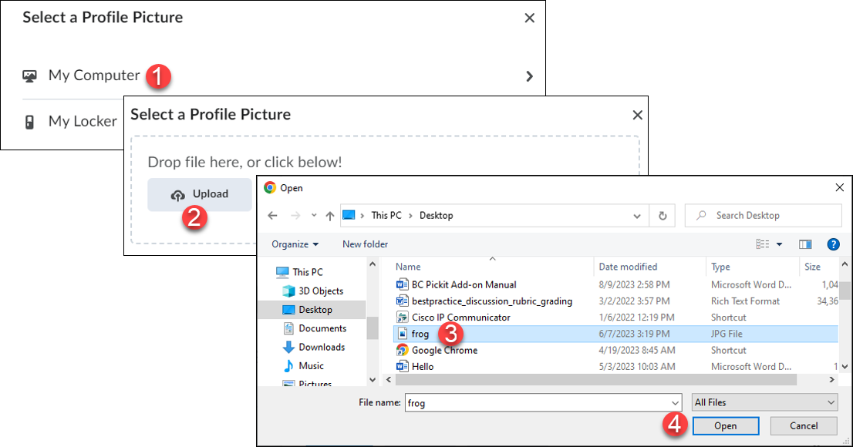
- Click the Add button.
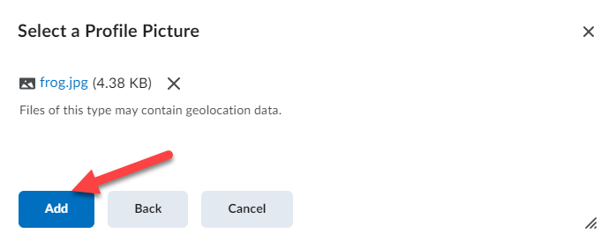

- Your new image will appear on the left side of the page.
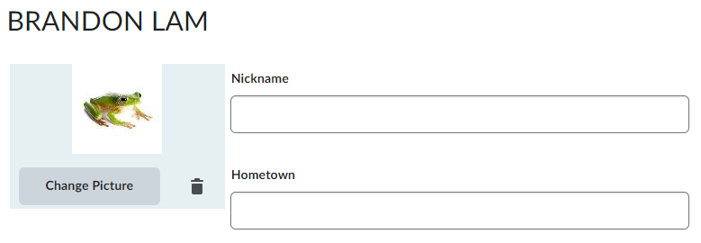

- Click the Save and Close button once you have edited and/or entered all your information.
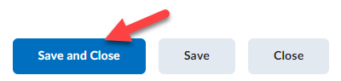

Viewing Another Student’s profile
Desire2Learn now allows you to view the profiles of other students in your online course.
- Click on Classlist from the navigation bar.
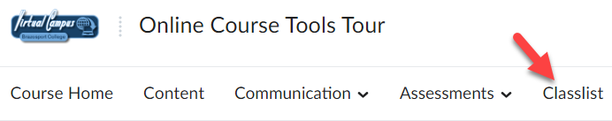

- A list will be populated showing all the students in the course.
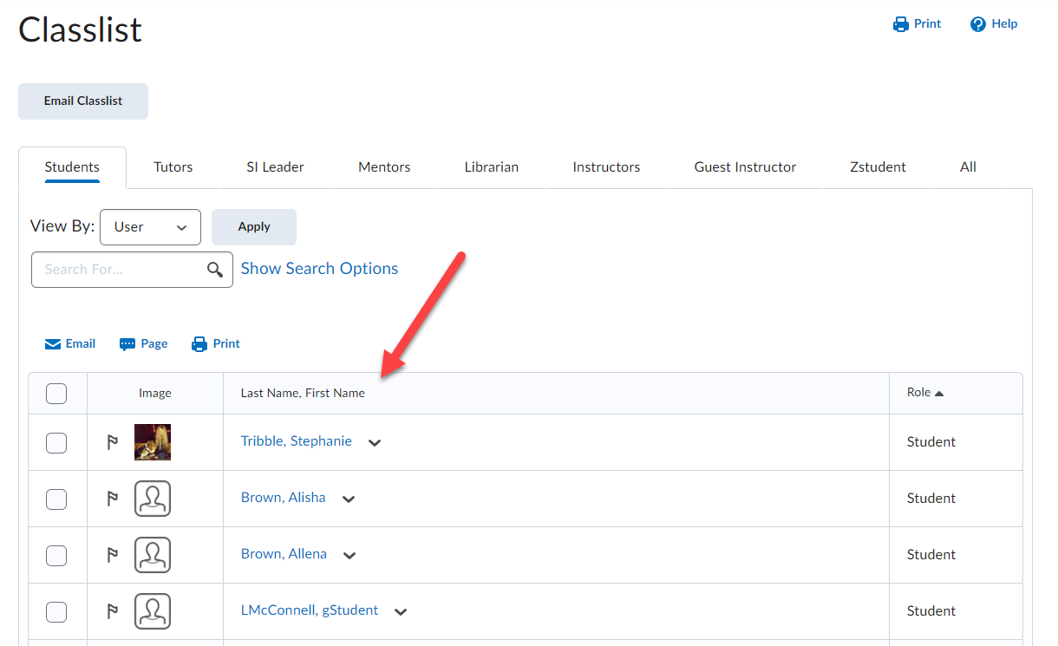

- To view the profile for a specific student, click on the image or image icon to the left of the student’s name.
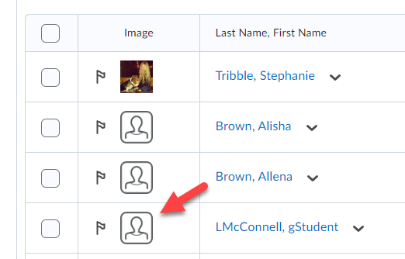
NOTE: A Green dot next to a student’s name indicates that they are currently online and logged into Desire2Learn.

- The page that appears will be the student’s profile.
