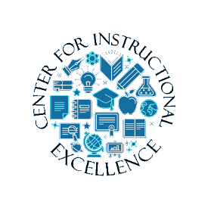
Course-related material (syllabus, lecture notes, required reading, etc.) are typically located in the content area. The content area is comprised of various modules that contain related course materials, often referred to as topics.
Viewing Content Pages
- Click on Content from the navigation bar (navbar).
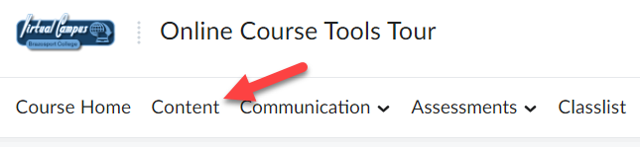

- To access course materials, click on a module from the Table of Contents sections (located on the left-side of the page) (1) and then click on the course material topic you would like to access (2).
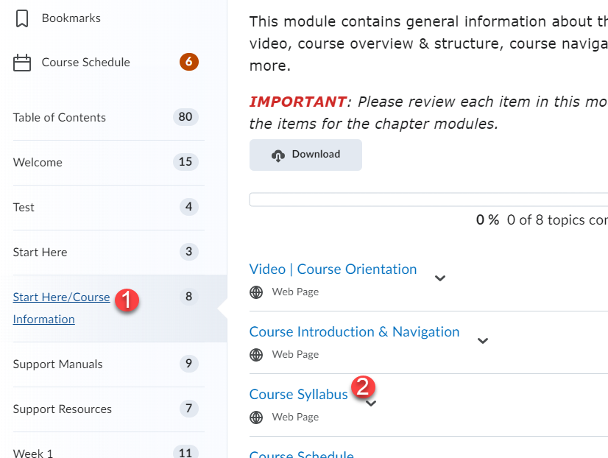

- The topic will open like the one shown below.
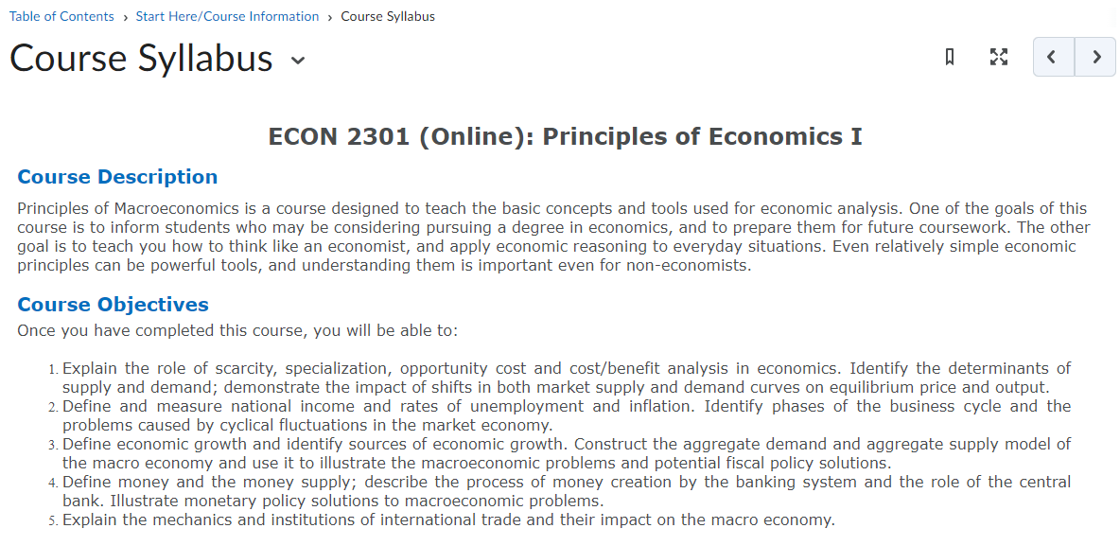

- Once the topic is open, use the Content navigation menu to move back/forward through topics (1), create bookmarks (2). Use the drop-down menu next to the topic’s name to leave feedback on the topic, or to download it (3).
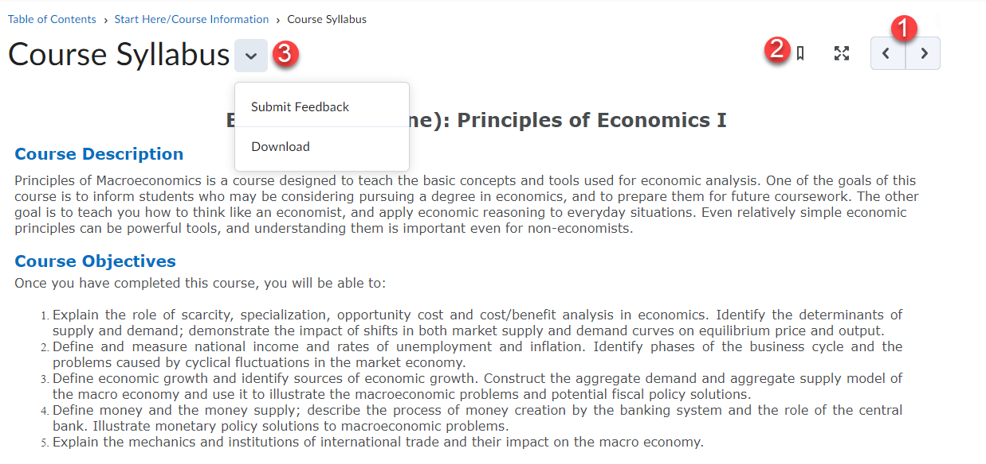

- Use the Side Panel (when viewing a topic) to jump quickly to another topic. Use the previous or next arrows to navigate between modules.
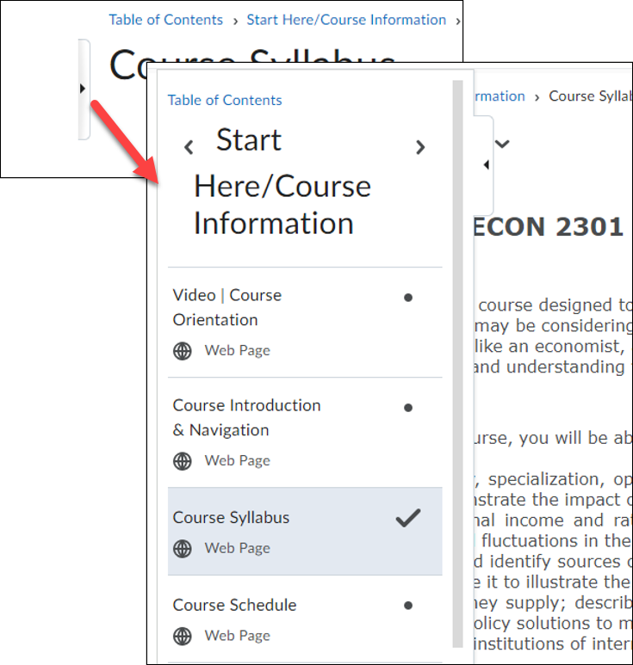

- If you need to print a topic, click on the Print button located near the bottom of the page.
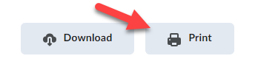

Progress Tracking
If applicable, D2L will keep track of the number of topics you have viewed in the content section of the course.
The progress bar shows your completion rate towards viewing all topics within a module.
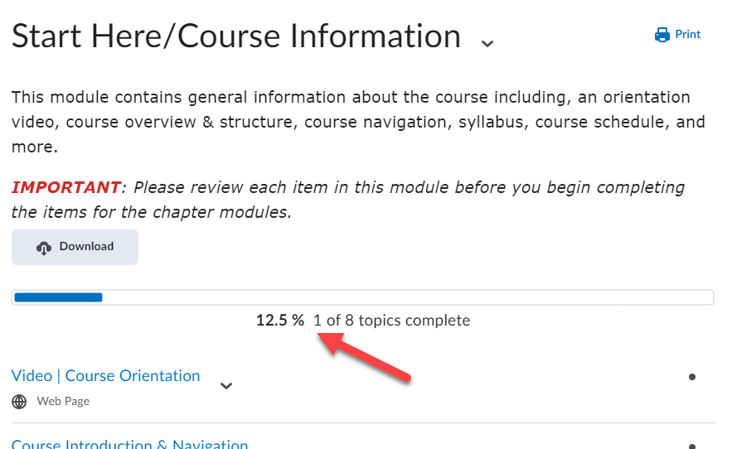

There are two types of tracking:
Automatic Tracking
Any topic you have not visited will be marked as incomplete (until you view it).

Manual Tracking
If your instructor chooses to use manual tracking, you will need to manually check completed for any topic you view and/or complete. To do so click the completion box next to content topic to mark it as completed.
