Viewing Grades & Your Student Progress

Grades
When your grades for particular course assignments, discussions, quizzes, etc., have been published they will appear on your personal Grades page in the course. In addition, your personal Grades page will also display any feedback from your instructor regarding your grades or performance on assignments and discussions.
- Click Assessments from the navigation bar (1) and click on Grades (2).
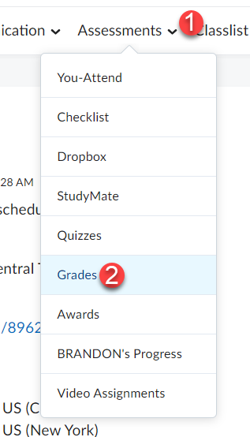
- Your Grades page will display all the assignments that will be graded for the course (1), your grades on graded assignments (2), and any comments for assignments and discussions left by your instructor (3). At the end of the course your Final Course Grade will also be viewable from your Grades page (4).
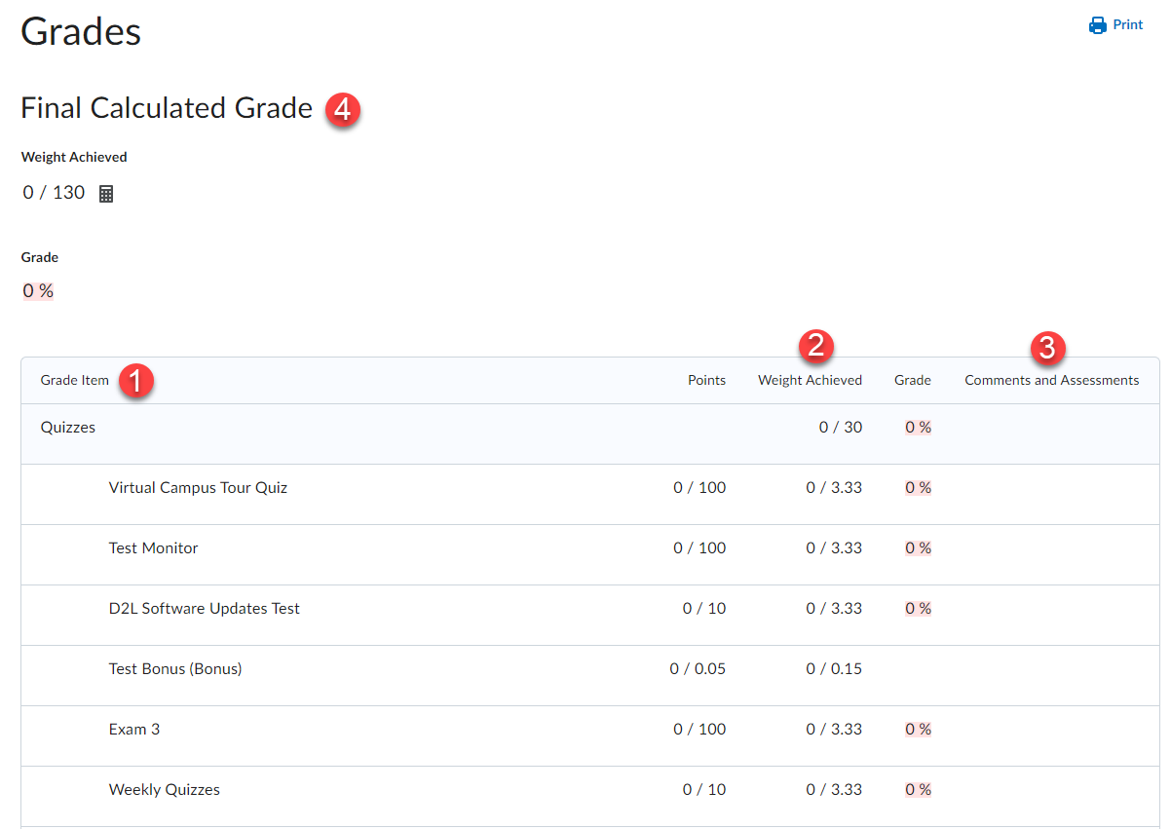

- If your instructor graded an assignment using a rubric, in the Assessments column for the assignment you will see a link to the graded rubric entitled View Graded Rubric. Clicking on the link will open the graded rubric for you to view it.
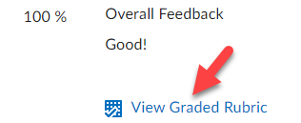

Student Progress
The Student Progress tool allows you to view your progress in the course.
- Click on Assessments from navigation bar (1) and select your “Progress” (2).
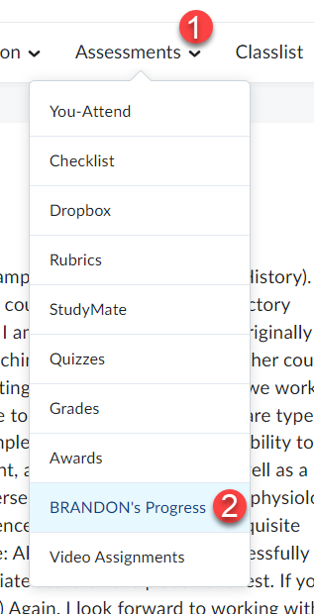

- On the left side of the page click on the content tab to view the content progression page.
